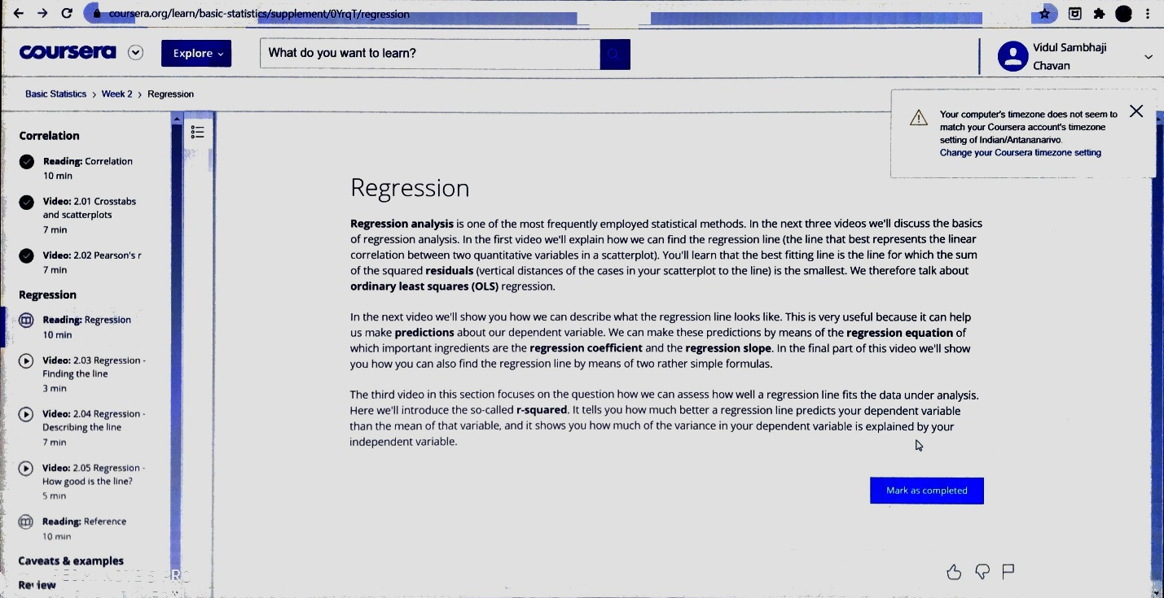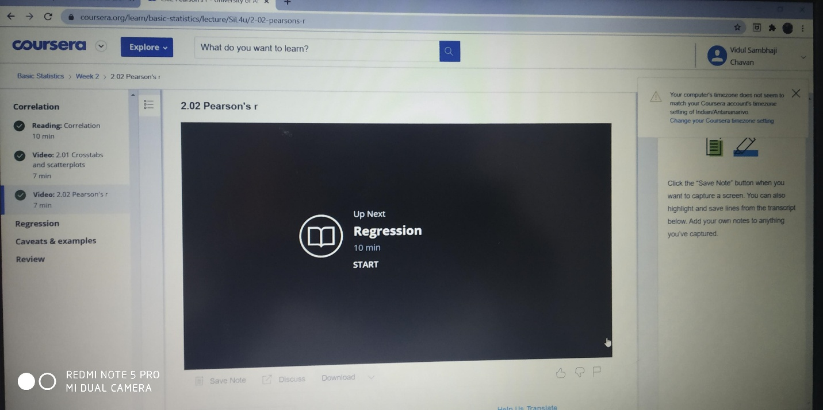**DAILY ASSESSMENT FORMAT**

|  |  |  |  |
| --- | --- | --- | --- |
| **Date:** | **21-07-2020** | **Name:** | **Nikhil Tejaswi** |
| **Course:** | **Basic statistics** | **USN:** | **4AL17EC104** |
| **Topic:** | **Week2** | **Semester & Section:** | **6TH SEM**  **B - SEC** |

1. 